1. PUT Command:

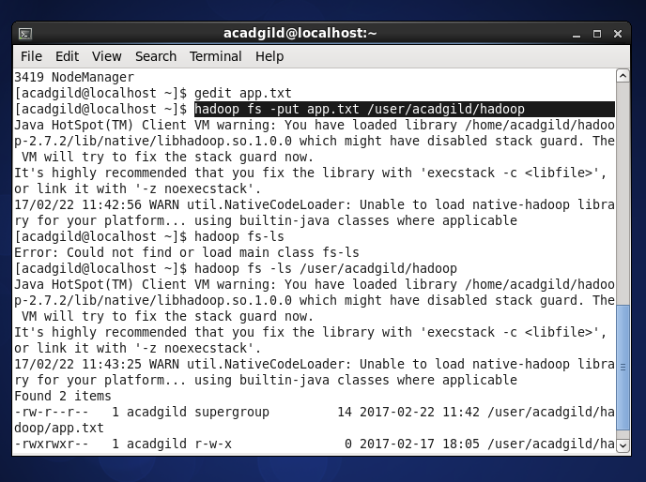

1. LIST Command:

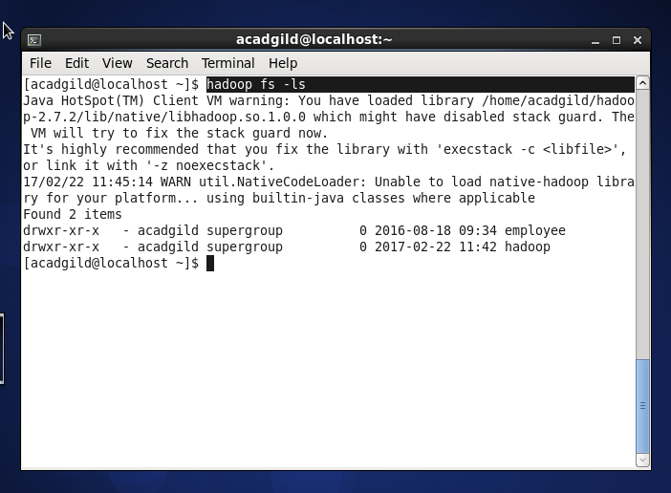

3)GET Command:

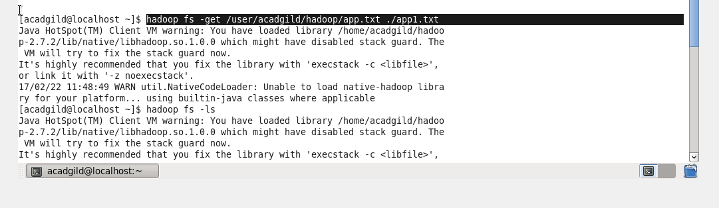

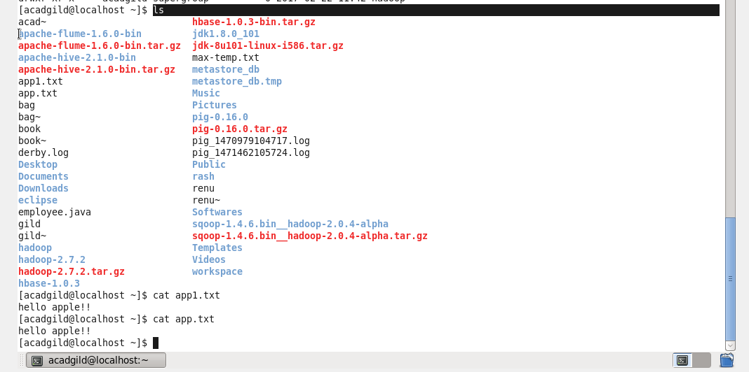

4)MAKE Command:

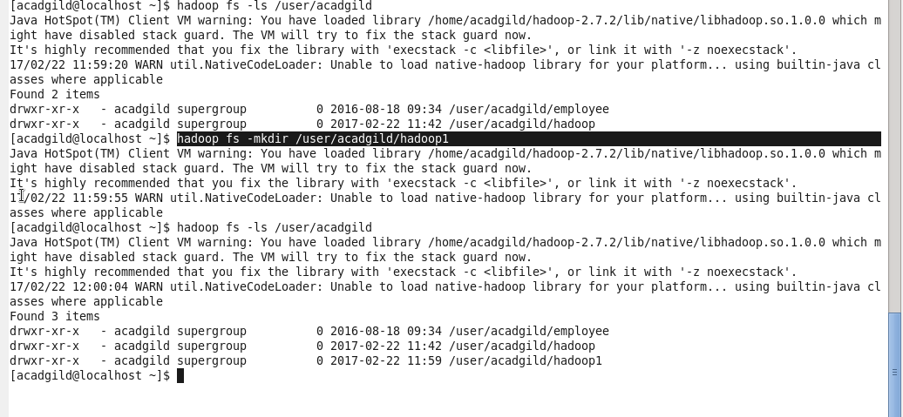

5) View Contents Of Particular File:

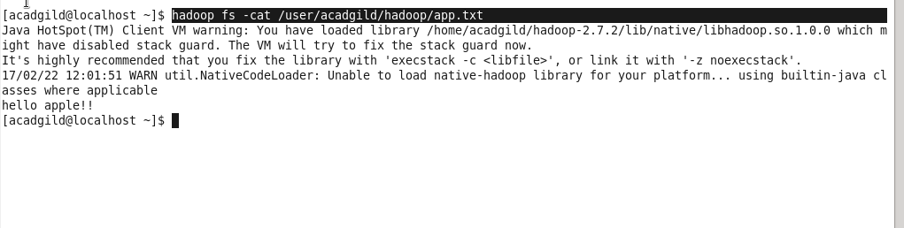

6)Duplicating a complete file inside the hdfs:

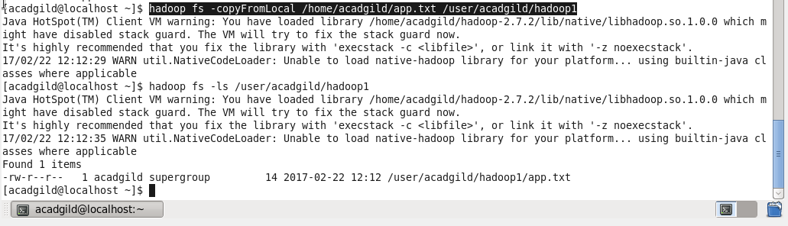

7) Duplicating a complete file from hdfs to local:

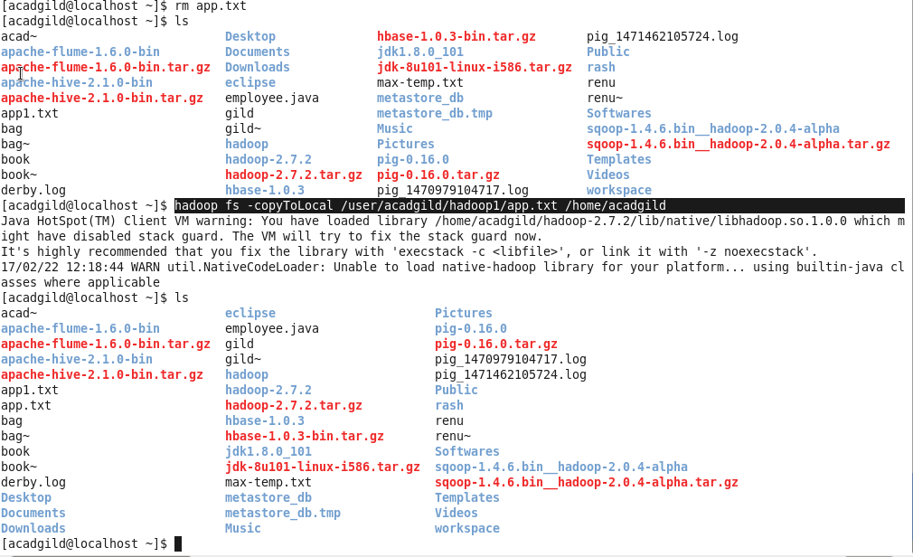

8) Removing a file:

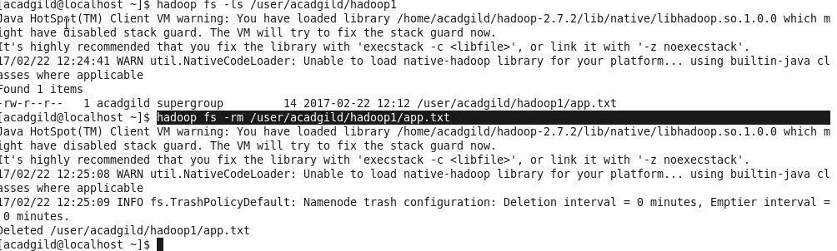

9)Run dfs fs to check utility:

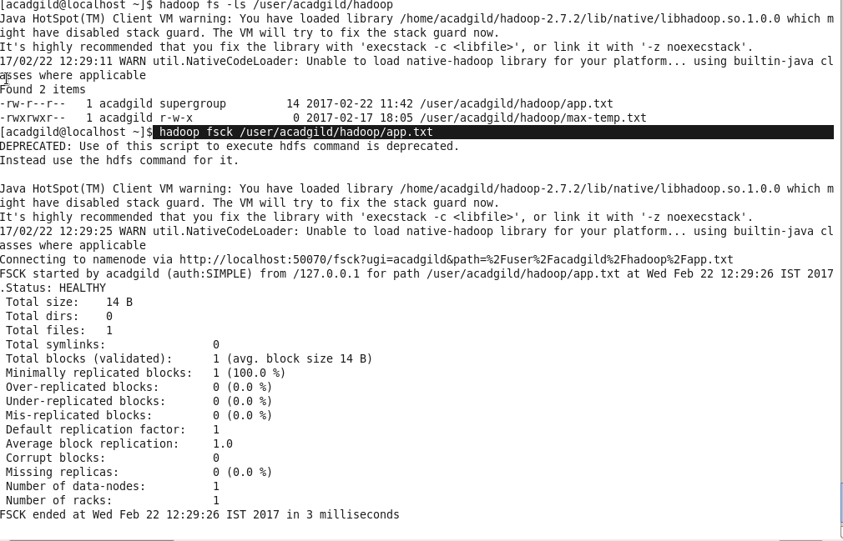

10) Run a cluster balancing utility:

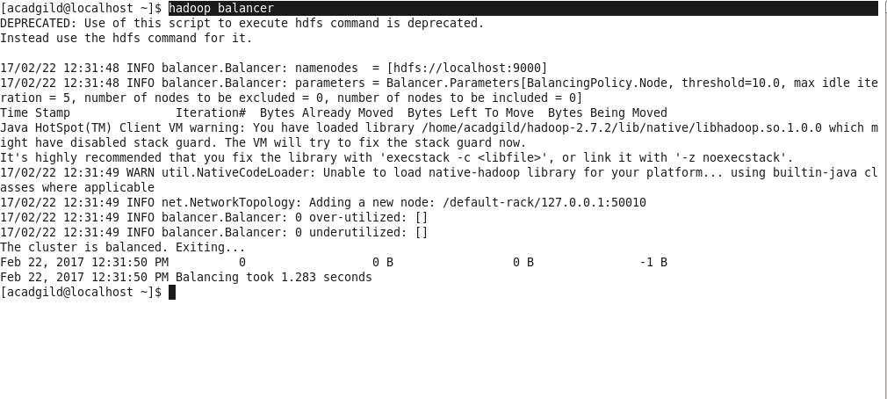

11) Check directory space in hdfs:

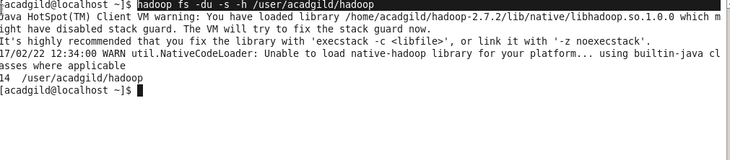

12) List all hdfs shell commands:

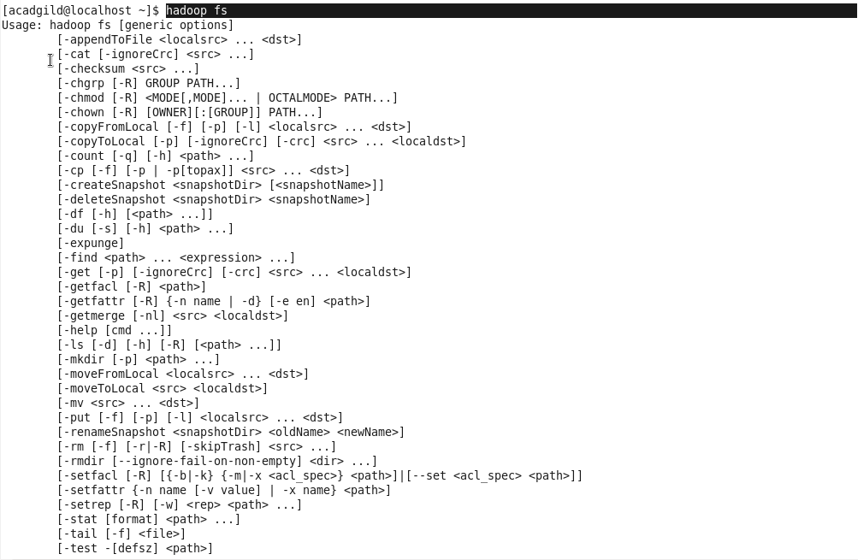

13) Asking for help:

